# **The 'Tasmanian Tiger' - an animal that went extinct 100 years ago - is making a comeback**

# **The 'Tasmanian Tiger' - an animal that went extinct 100 years ago - is making a comeback**

By [news section](https://www.hindutamil.in/author/1361-News%20Desk)

Modified: 20 Sep, 23 02:57 pm

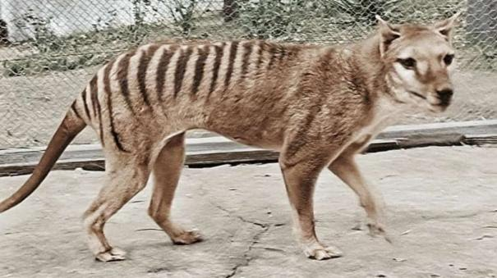

**Sydney:** Researchers at the University of Melbourne have said that they are actively trying to revive the Tasmanian tiger, an animal that died out about 100 years ago.

The Tasmanian tiger, also known as the Thylacine, became extinct in the rest of the world except the island of Tasmania, Australia, about 2,000 years ago due to climate change and poaching. While there were an estimated 5,000 Tasmanian tigers in Tasmanian forests before European settlement, they were regularly poached in the early nineteenth century as a threat to livestock. The world's last Tasmanian tiger died in 1936 at Hobart Zoo in Tasmania. The tiger's name is Benjamin.

Since then, researchers have been trying to revive the Tasmanian tiger for a long time. Currently, researchers at the University of Melbourne are trying to bring back this extinct animal using advances in ancient DNA recovery and artificial breeding. They hope the Tasmanian tiger can be brought back to earth after recovering an RNA sample that helps revive the carnivore.

Ribonucleic acid (RNA) is a genetic material present in all cells. It has structural similarities to DNA. The researchers recovered the RNA from the body of a Tasmanian tiger that had been preserved in a museum in Sweden since 1891.

This effort to bring the Tasmanian tiger back to life is being carried out in collaboration with Colossal Biosciences, headquartered in Texas, USA. It is also said that 15 million US dollars are being spent on this project. It is named Tasmanian tiger because it has lines like a tiger on its body. Instead it had the look of a wolf.